

**American International University-Bangladesh (AIUB)**

**Department of Computer Science**

**Faculty of Science & Technology (FST)**

**Summer 19-20**

**<** Your Business Assistant >

**Software Requirement Engineering**

**Sec:B**

**Project submitted**

**By**

**SULTANA, SAMIMA | ID: 16-32012-2**

**JAHAN, TASNIM | ID: 17-33455-1**

**IBNA-AL-HASIB, MD| ID: 17-33313-1**

**BOIRAGI, KALLOL | ID: 17-33626-1**

**1.** **PROBLEM DOMAIN**

**1.1 Background to the Problem**

There are a total 1315 Businesses and Services according to yellow pages listing in Bangladesh. Among them the core problem is the distribution of work from Corporates to agencies. One of the top problem agencies are facing initially when they come to market is to get enough leads and proper work. And on the corporate side one of the top problems their managers face is finding a competitive and good agency who can do their work properly. More times than not, Service seekers find it difficult to get their bearings about where to start from, if they are to seek any service provider. It has been observed that there is a lack of listing or coherent arrangement of service providers and this makes it harder for firms or businesses to make informed decisions. And lack of exposure also affects small and new service holders. Another big problem in the industry is “Client Acquisition”. A large sum of money and time is spent in acquisition of clients which sometimes might prove to be futile. This leads up the opportunity cost. And because of lack of visibility companies are running on 30% efficiency rate.

So, From the all the analysis the main problem that occurs if we listed down:

1. No complete List of corporates and agencies

available online.

2. No way for Businesses to make informed

decisions.

3. New and small firms have lack of visibility.

4. Late payments.

So, from all the core problem is:

“Lack of efficiency, connectivity and transparency amongst service seekers and service providers in the B2B ecosystem.”

**1.2 Solution to the Problem**

After analyzing the problems, the solutions require is a bridge between corporates and agencies where they can communicate and share their work neutrally. So we are proposing a platform named YBA (Your Business Assistant). Our goal is to bring down the lead generation cost for each company through a YBA. Our solution is to deal with the problem is:

■ Allow large and small companies to access prices and compare.

■ Provide a neutral platform for sellers to showcase their services.

■ Facilitate financial transactions between seekers and providers.

■ Provide efficient management processes.

■ Facilitate exposure for small and new business owners to potential clients.

■ Decrease opportunity cost - less time, less money; make sure that sellers don't have to spend more time on getting clients but instead can utilize said time on operations or ideation.

■ Provide a learning center for the initial starters and startups in the market.

But this is not in total a new solution to the market. There is existing softwares which provides these kinds of services:

1. Yellow pages

2. Clutch.co

3. UPcity

But they are not our direct competitor because all of them help corporates and agencies to get listed online. They don’t solve the core issue of “Lead generation Cost and Financials”. Our services unique value is to aid in decreasing lead generation cost and also getting payments easily and in a secured way. YBA is providing a one stop solution for all kinds of lead generation, visibility and payments related problems.

**2. Solution Description**

**2.1 System Features**:

**User Category**:

1. Corporates/Businesses: who is willing to post their work

2. Agencies: who will get the work

3. Admin

**Features of the system**:

**Admin**:

**Admin Register:** The first admin/ owner of the system will be able to register to the admin section after then he can add multiple admin. But no new admin can register directly to the system.

**Admin Login:** Admin will be able to login to the system with the password given to the admin.

**Remove User:** Admin will have all the power to remove/ban users from the system.

**Hierarchical system for admin:**

There are different roles for admin:

**a.** **Owner/Admin of the system:** Who will be able to monitor and control all the system and add/remove another admin, moderator and user.

**b.** **Moderator:** He will be able to monitor and control the update delete and create any field in blog/content. And will be able to delete/ban users from the system.

**c.** **Content Editor**: He will be able to view all the analytics of the content part and edit the contents to the system but not be able to delete/ban any user.

**Verification of the users:** With each registration admin will verify manually both corporate and agencies and then add them to the system. .

**Validate the posted work by the corporates:** Moderators and Admins both will validate the work posted by the corporates.

**Corporates/Businesses:**

**Register:** Corporates will have to register to the system to get access. Email Authentication will be confirmed by email and also verification of their trade license.

**Two factor Authentication:** During the registration users will be questioned if they want to enable two factor authentication or not if they enable it. System will ask them three personal questions so that it can verify if they forgot username/email and password.

**Login:** After registering and authentication they will be able to login to the system. They will have to login to the system using their email and password.

**Forget Password:** If they forgot the password there will be a section to recover their password using their email.

**Get a tour:** Before registering on the landing page they will be able to get a free tour about the working of the system.

**List of work:** Without registering to the system corporates/businesses will be able to see top 3 agency portfolios and their list of work but if they want to hire them they will have to register in the system.

**Dashboard:** Each corporate will have a dashboard. In the dashboard they will be able to:

a. Create their business profile

b. In the profile they can upload a work and

post it to the system.

c. They can manage the selected platform

contact with the agencies through YBA

platform.

d. Manage their financials

e. Watch the work performance and manage

the timeline online.

**Post a Work:** In the platform they can post a work according to the given instructions and provide details files and attachments.

**Manage the agencies:** They will be able to manage the agencies they are pitching. And Select the best one according to their choice and contact with them through the portal.

**Payment:** Corporates will be able to manage their payment system using our platform using provided online banking agents.

**Give Feedback and ratings to agencies:** According to agencies work performance corporates will be able to give proper feedback with ratings.

**Agencies:**

**Register:** Agencies will have to register in the system with proper documents. After verification by the admin they will be listed to the system.

**Two factor Authentication:** During the registration users will be questioned if they want to enable two factor authentication or not if they enable it. System will ask them three personal questions so that it can verify if they forgot username/email and password.

**Login:** After registering and authentication they will be able to login to the system. They will have to login to the system using their email and password.

**Forget Password:** If they forgot the password there will be a section to recover their password using their email.

**Packages:** There will be three packages to for the agencies:

**Free Subscription:** Agencies will be able to subscribe and get listed free for 3 months by providing their email address. In free section agencies will be able to:

1. Get listed using their organic ratings and

according to work feedback.

b. Get a cloud space for showcasing their work

and portfolio.

c. Can be able to work with 5 different companies and 22

projects.

**Featured/Premium Subscription:** Agencies will have to pay a certain amount and milestones for getting the following features:

a. Get listed using organic and also pay YBA to be

in the top section.

b. Get a cloud space for showcasing their work

and portfolio.

c. YBA will provide their social media posts

(Static and infographic).

d. YBA Leaning platform will be enabled specifically for their

employees.

**Platinum:**

1. Get listed using organic and also pay YBA to be in the top section.
2. Get a cloud space for showcasing their work and

Portfolio.

1. YBA will provide their social media posts ( static and

Infographic).

1. YBA Leaning platform will be enabled specifically

for their employees.

1. Blog Post that will be visible in the landing page.

f. Listed and visible in the landing page to the

corporates.

g. Details analysis of their social media and YBA

platform will be given.

**Dashboard:** Each agency will have a dashboard. In the dashboard they will be able to:

a. Create and update their profile.

b. They can upload their work and portfolio.

upto a certain number according to different

subscription process).

c. Manage their pitches according to the given

templates.

d. Manage all the work from different

corporates/businesses.

e. Watch the work performance and manage the

timeline online.

f. Manage their finance online.

**Get payment easily:** Rather than waiting for a long time they will be able to get payments easily and quickly from YBA by using online banking.

**Give Feedback and ratings to the corporates:** Agencies will be able to give feedback and ratings to the corporates.

**2.2 UML Diagrams:**

**Use-Case Diagram:** The following is the use case diagram of the system. In our use case we have several types of actors:

1. User

a. Corporate

b. Agencies

2. Admin

a. Owner

b. Moderator

c. Editor

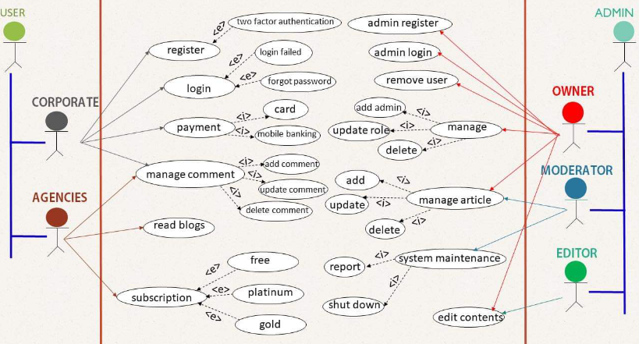

**Activity Diagram**:

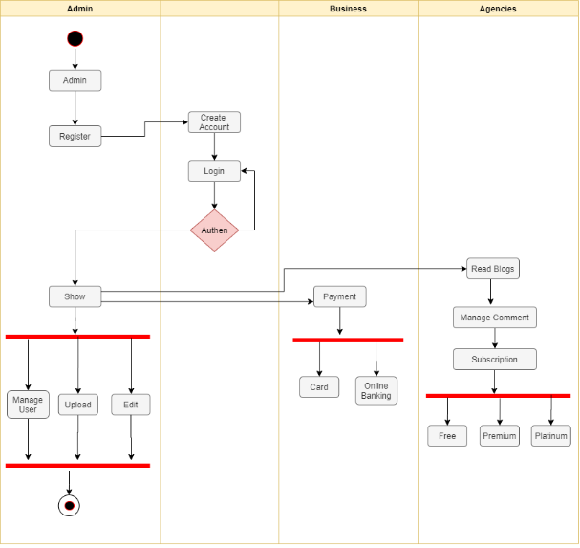

**ER Diagram:**

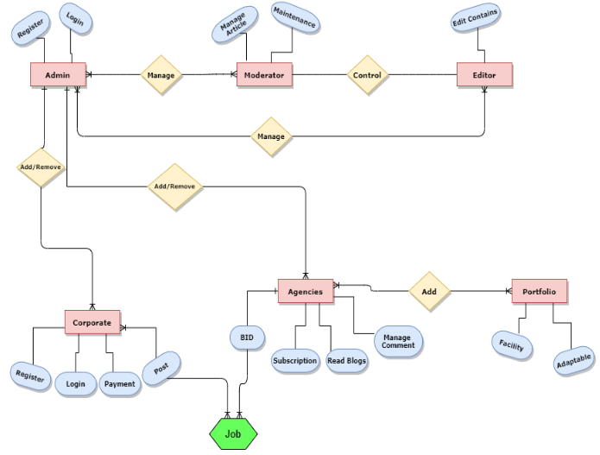

**Class Diagram:**

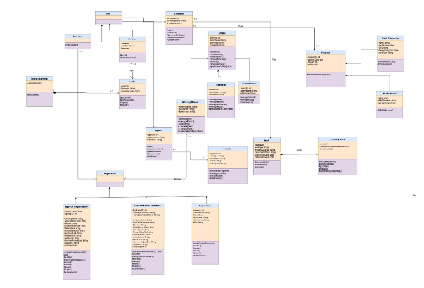

**3. Social Impact**

In my opinion,There will be a huge impact in the society from this project.

As this project basically, makes a stage for all the businesses. The provider and the businesses will both be benefited. As there are very few stages like this –

The society will take this idea as a positive impact. This project can positively influence how society operates. It can build and maintain social capital through its core operations, the goods and services it provides and the activities supported, through increasingly global and complex supply chain.

**4. Development plan**

The Software Development Life Cycle simply outlines each task required to put together a software application. This helps to reduce waste and increase the efficiency of the development process. Monitoring also ensures the project stays on track, and continues to be a feasible investment for the company.

Many companies will subdivide these steps into smaller units. Planning might be broken into technology research, marketing research, and a cost-benefit analysis. Other steps can merge with each other. The Testing phase can run concurrently with the Development phase, since developers need to fix errors that occur during testing. The Seven Phases of the SDLC diagram of the stages or phases of SDLC

**1. Planning**

In the Planning phase, project leaders evaluate the terms of the project. This includes calculating labor and material costs, creating a timetable with target goals, and creating the project’s teams and leadership structure. Planning can also include feedback from stakeholders. Stakeholders are anyone who stands to benefit from the application. Try to get feedback from potential customers, developers, subject matter experts, and sales reps. Planning should clearly define the scope and purpose of the application. It plots the course and provisions the team to effectively create the software. It also sets boundaries to help keep the project from expanding or shifting from its original purpose.

**2. Define Requirements**

Defining requirements is considered part of planning to determine what the application is supposed to do and its requirements. For example, a social media application would require the ability to connect with a friend. An inventory program might require a search feature. Requirements also include defining the resources needed to build the project. For example, a team might develop software to control a custom manufacturing machine. The machine is a requirement in the process.

**3. Design and Prototyping**

The Design phase models the way a software application will work. Some aspects of the design include: Architecture – Specifies programming language, industry practices, overall design, and use of any templates or boilerplate User Interface – Defines the ways customers interact with the software, and how the software responds to input Platforms – Defines the platforms on which the software will run, such as Apple, Android, Windows version, Linux, or even gaming consoles.

**4. Software development**

This is the actual writing of the program. A small project might be written by a single developer, while a large project might be broken up and worked by several teams. Use an Access Control or Source Code Management application in this phase. These systems help developers track changes to the code. They also help ensure compatibility between different team projects and to make sure target goals are being met. The coding process includes many other tasks. Many developers need to brush up on skills or work as a team.

**5. Testing**

It’s critical to test an application before making it available to users. Much of the testing can be automated, like security testing. Other testing can only be done in a specific environment – consider creating a simulated production environment for complex deployments. Testing should ensure that each function works correctly. Different parts of the application should also be tested to work seamlessly together—performance test, to reduce any hangs or lags in processing. The testing phase helps reduce the number of bugs and glitches that users encounter. This leads to a higher user satisfaction and a better usage rate.

**6. Deployment**

In the deployment phase, the application is made available to users. Many companies prefer to automate the deployment phase. This can be as simple as a payment portal and download link on the company website. It could also be downloading an application on a smartphone. Deployment can also be complex. Upgrading a company-wide database to a newly-developed application is one example. Because there are several other systems used by the database, integrating the upgrade can take more time and effort.

**7. Operations and Maintenance**

At this point, the development cycle is almost finished. The application is done and being used in the field. The Operation and Maintenance phase is still important, though. In this phase, users discover bugs that weren’t found during testing. These errors need to be resolved, which can spawn new development cycles. In addition to bug fixes, models like Iterative development plan additional features in future releases. For each new release, a new Development Cycle can be launched.

**5. Marketing Plan**

One of the easiest ways to promote your software online is to have it available for download on as many software downloading sites as possible. Go for software sites that provide free as well as paid software. Also, spend some time in tracking which sites bring you more traffic, and formulate your marketing strategy accordingly. Software developers with a dedicated website for their products and services can also obtain more back-links with this marketing strategy.

**PAD it**

Not literally. For desktop applications, creating a PAD (Portable Application Description) file makes their submission on software distributing websites efficient. Today, more than 50,000 software publishers distribute over 250,000 unique application using PAD files. PAD files provide a standard way to distribute software online. It is a machine-readable .XML document, which relieves authors from writing lengthy and informative descriptions for applications. Additionally, webmasters appreciate software submission with PAD files as it allows them to automate the app listing. All PAD submission, specification, and support are handled by the Association of Software Professionals’ PAD committee.

Participate in online discussions

As a part of your research work, find some online forums where people talk about software features, releases and other related topics. But before getting involved in discussions, know that people visit these websites in search of information. Voice your opinion like a subject-matter expert, not as a promoter. If you sound like you are here only to promote your software products, most readers will ignore what you have to say. Besides, some forums may also block you for explicit publicity.

**Write blogs, articles and guest blog**

Publishing blog posts and writing articles with relevant information is your best shot to expand your reader base and thus, creating customers and clients. But here as well, you need to keep a balance between information and promotion. Present your products as a part of the solution, and avoid

explicitly pitching for its sale. If you don’t already have a reader base then you can promote your software through guest blogging.

**Build trust for your software through promotional offers**

If you are new in business, then your first goal is to make your audience believe that you are providing genuine software products. For desktop applications, letting people use a free trial version is the most effective way to tell them it will work for them. You can also offer a freemium version of your app with some basic features to tell people what your application is about. This marketing strategy works beautifully for promoting mobile apps. Providing money back guarantee for paid apps, and using software safety badges are other ways to build trust about your software products. Additionally, software publishers with a website can invite geeks and tech writers to write reviews and feature them as public opinion about their software products.

**Use social media**

Did we forget social media? Absolutely not! Haven’t you heard “Save the best for last”?

Start off with optimizing you Facebook, twitter, Google+, LinkedIn and other profiles. Start posting relevant and interesting information around your new release. Engage your audience by holding contests, short surveys and other techniques. You can also use visual social media like Pinterest and Flickr to give people an idea about the look and feel of your software and what to expect from your new release. If you are launching a mobile app then social media is your primary target, since your target audience is smartphone users. Get expert advice to promote your mobile app on social media.

**Paid Marketing**

Technology is evolving at lightning speed. Amidst this rush, not many developers can afford to spend too much time in promoting their software and wait for results. Instant exposure with long term results is what everyone is looking for and everyone needs. This is where role of professional marketers comes into play.

**Invest in SEO**

If you have a business website, one thing that you need to continuously laboriously work upon to boost your online software sales is to have your website optimized for better search engine ranking. You need to continuously add fresh content to your site based on tested keywords, monitor your website performance, improve website design and its usability, and work upon improving your link popularity. Pheew! Sounds like a lot of work. It is, but equally necessary.

With a professional SEO team at your side, this overhead could become a merry walk.

Want to bring more traffic to your site and multiply your app downloads?

Get Started

**Create an explainer video**

Having created an explainer video on your software release can make miles of difference in your marketing campaign. But you need to make sure that your video is more than just an advertisement. It should provide the viewers the information they are looking for. Explore this business explainer video created by FATbit to

get ideas on video script. Hire a trusted and creative firm that understands your market needs and put your message across visually in a compelling way. And don’t forget to promote it on various video-sharing platforms and social media.

**Hire a marketing team**

If you think you can’t spare time and efforts for marketing, which is usual for developers, then hiring a trusted marketing firm can provide you an end-to-end solution. Of course it will cost you a few extra bucks, but in return will save you a lot of time, and will bring more positive results.

Naturally, there could be many wrong combinations, but only a few right ones. So, it is better to have professional help in formulating your marketing strategy instead of ineffectively putting lots of efforts and resources on your own.

**6. Cost and profit analysis**

|  |  |
| --- | --- |
| **Particulars** | **Total** |
| **Profits** |  |
| A. Increase in Revenue | 2,000,000 |
| B. Increase in Additional Revenue | 500,000 |
| **Total profits(A+B)** | **2,500,000** |
|  |  |
| **Costs** |  |
| D. Salary Cost | 800,000 |
| E. Utility Cost | 150,000 |
| F. Salary of New Employees | 300,000 |
| G. Cost of Additional Hardware and Software | 200,000 |
| H. Software License | 50,000 |
| I. Marketing Cost | 100,000 |
| **Total Costs (D+E+F+G+H+I)** | **1,600,000** |
|  |  |
| **Benefits Cost Ratio** | **1.56** |